HOME AND ABOUT CODE:
<!DOCTYPE html>
<html lang="en">
<head>
<meta charset="UTF-8">
<meta name="viewport" content="width=device-width, initial-scale=1.0">
<link rel="stylesheet" type="text/css" href="portfolio.css">
<title>portfolio</title>
</head>
<body>
<div class="header">
<nav>
<h1><span>PORTFOLIO</span></h1>
<ul>
<li><a href="#">Home</a></li>
<li><a href="#">About</a></li>
<li><a href="#">Skills</a></li>
<li><a href="#">Contact</a></li>
</ul>
</nav>
<div class="content">
<h3>Hi, My Name Is <span>Thirusakthivel.R</span></h3>
<h2>I'm a FULL STACK DEVELOPER</h2>
</div>
</div>
<section class="about">
<div class="main">
<img src="about.jpg">
<div class="about_text">
<h2>ABOUT ME</h2>
<h3>Full Stack Developer</h33>
<p>
Lorem ipsum dolor sit amet consectetur adipisicing elit.<br>
Tempora porro amet laudantium at in mollitia hic, unde<br>
reiciendis, sed modi similique veniam corrupti!<br>
Fugiat voluptas ex quasi labore optio enim?
</p>
</div>
</div>
</section>
</body>
</html>

HOME AND ABOUT CSS:
*{
color:white;
font-family: Arial, Helvetica, sans-serif;
box-sizing: border-box;
}
.header{
font-size:30 px;
width: 100%;
height:100vh;
background-image:url("home.png");
background-position:center;
background-repeat: no-repeat;
background-size: cover;
}
nav{
display:flex;
align-items: center;
justify-content:space-between;
padding:15px;
}
nav ul li{
list-style-type: none;
display: inline-block;
padding: 15px 30px;
margin-right:45px;
text-decoration: none;
font-weight: bold;
font-size:15px;
}
nav ul li a:hover{
color:rgb(162, 234, 220);
transition:0.3s;
}
.content{
position:absolute;
margin-left: 20%;
margin-top: 20%;
font-size:15px;
font-weight: bold;
}
h1 span{
color: brown;
}
.content h2:hover{
color:rgb(224, 139, 151);
background-color:rgb(53, 7, 14);
}
h3 span:hover{
color: rgb(198, 57, 83);
}
.main img{
width:35%;
height:50%;
}
.about{
background-image:url(home.png);
width:100%
padding: 100px 0px;
}
.main{
width:100%;
display: flex;
align-items: center;
justify-content: space-around;
}
.about_text{
font-size: 30px;
text-transform: capitalize;
margin-bottom:20px;
margin-right:100px;
}
.about_text h2{
font-size: 15px;
text-transform: capitalize;
letter-spacing:3px;
margin-bottom:20px;
}
.about_text h2{
font-size:15px;
text-transform: capitalize;
letter-spacing:2px;
margin-bottom:20px;
}
.about_text p{
font-size:12px;
text-transform: capitalize;
letter-spacing:0.5px;
margin-bottom:20px;
color: aquamarine;
}

OUTPUT HOME AND ABOUT:




MYSKILLS CODE:
<!DOCTYPE html>
<html lang="en">
<head>
<meta charset="UTF-8">
<meta name="viewport" content="width=device-width, initial-scale=1.0">
<title>myskills</title>
<style>
*{
background-color: black;
}
body{
color: aliceblue;
}
h1{
text-align: center;
color: whitesmoke;
}

h1:hover{
background-color: aqua;
transition: 0.2s;
}
li{
list-style-type: none;
display: inline-block;
padding: 15px 30px;
align-items: center;
justify-content:space-between;
text-decoration: none;
font-weight: bold;
font-size:15px;
background-color:blue;
margin-left: 120px;
}
</style>
</head>
<body>
<div>
<h1>MY SKILLS</h1>
<ul>
<li>HTML</li>
<li>CSS</li>
<li>JAVASCRIPT</li>
<li>REACT</li>
</ul>
</body>
</html>

OUTPUT:
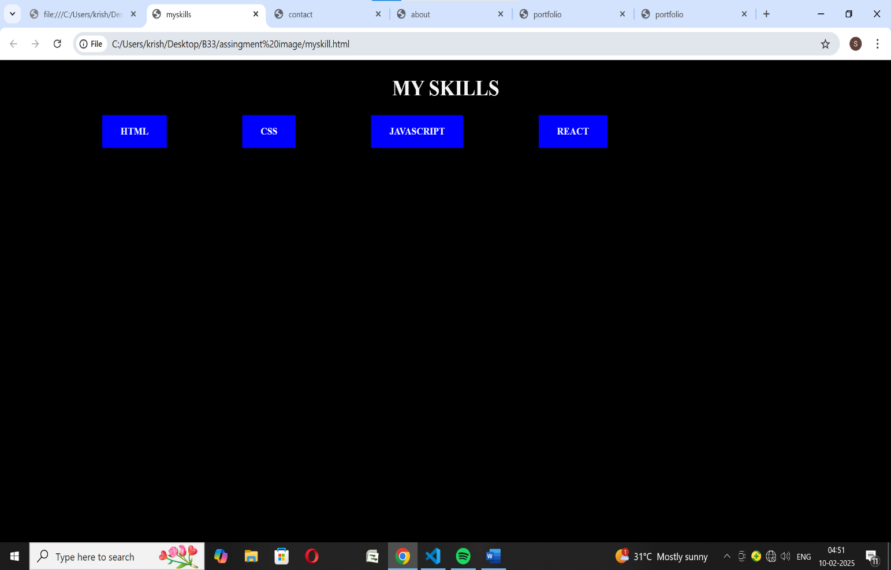

CONTACT CODE:
<!DOCTYPE html>
<html lang="en">
<head>
<meta charset="UTF-8">
<meta name="viewport" content="width=device-width, initial-scale=1.0">
<title>contact</title>
<style>
*{
color: black;
}
h1{
text-align:center;
text-transform: capitalize;
background-color: aqua;
color:black;

}
</style>
</head>
<body>
<h1>contact us</h1>
<table>
<form>
<tr>
<td><label>Name</label></td>
<td><input type="text" name="name" value=""></td>
</tr>
<tr>
<td><label>Phonenumber</label></td>
<td><input type="number" name="Phonenumber" value=""></td>
</tr>
<tr>
<td><label>Email</label></td>
<td><input type="email" name="Email" value=""></td>
</tr>
<td><label>Adress</label></td>
<td><textarea></textarea></td>
</tr>
<tr>
<td><input type="submit" value="submit"></td>
</tr>

</form>
</table>

</body>
</html>
OUTPUT:
